En Plein Air Painting – Getting Started
First Lessons with a Master

Background:
In the early nineteenth century, something happened that changed the way artists could approach their work: paints began to be available in pre-mixed form, and new containers for the paints, in the form of tubes that could be recapped became available. This allowed artists to paint outdoors; paint was expensive and not to be wasted. Having tubes to re-close allowed painters to preserve the paint, carry it wherever they wanted to go, and to save time by not having to mix their own paints. Portable easels called “pochades” became available to meet the growing need to paint outdoors, or “en plein air”.
Plein air painters have to paint quickly. Sometimes they have uninvited guests who would like to watch them work (which may not be tame), so it is of the utmost importance that the artist work quickly.

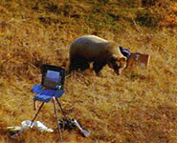
Photo courtesy pbs.org

For a beginner plein air painter, the amount of detail in the outdoor environment can be daunting to paint. An experienced instructor encourages the beginner to overcome potential sensory overload by using a teaching tool: having the student paint an existing painting. This also gives the student a direct correlation between what they see and what the instructor saw/painted, where painting outdoors has so much space, the point of view varies greatly from person to person.

This lesson uses the painting from a reference painting method as the first step to teach en plain air painting. It is assumed the student has painted before, and has knowledge and experience with mixing paints, preparing the canvas with gesso, and all the basic vocabulary terms of oil painting. It is beyond the scope of this learning module to train complete beginners in this specialty.

The Six major components of behavior modeling are:

- Prescribed critical steps/behaviors
Critical behaviors are identified, outlined and detailed.
- Credible model
A master painter has been consulted as the Subject Matter Expert (SME) for this module. However, the instructor using it does not have to be a master painter, but should be at least at the expert level. It is necessary to have a very high level of expertise so the learners are not misguided; determining color, depth, having a high level of control over the medium, and having a high level of ability to coach in oil painting technique are considered baseline for this course. It is permissible for the instructor to use video modeling in addition to their own demonstrations, if they feel it would be beneficial for the learner.
- Skill practice exercises
During the module, face-to-face instruction and practice will be expected. In painting technique, it is best to allow the learner to experiment, but to have a live instructor available who can gently coach in aspects that may be lacking or not understood by the learner. Although a great degree of independence is desired, the instructor should be available for answering questions/solving technical problems at all times.
- Specific feedback & social reinforcement
Through this module, both the instructor and peer artists may provide feedback. More experienced peers can be very helpful in answering simple questions (such as choice of paint for the initial palette), but more complex problems, such as how to blend unlike colors along an edge, should be referred to the instructor.
- Transfer strategies
As the learner progresses in artistic capacity, knowledge, and technical skill, the level of difficulty of the assigned painting to copy is increased. It is expected that the learner will practice on their own as they are able, and when they are able (when weather permits).
- On-the-job reinforcement
It is expected that the learner will take notes for themselves based on the individual coaching given by the instructor; this cannot be generalized, as it varies from learner to learner. It is known that artists tend to do the same thing unless they are tutored to do otherwise, so the willingness of the learner to take feedback and apply it to their work is essential to the learning process. Support is in the form of the learner’s practice at home, and peer-to-peer practice in the form of group painting trips (as in with plein air society trips), and also in future workshops that the learner also has as an option. It is also expected that a serious art student will be constantly learning through reading, studying the work of other artists in museums and galleries, and consulting other instructors if astute instruction is available elsewhere.

Prescribed Critical Steps/Behaviors:
The Instructor delineates the steps for what to look for (how to see) the designated painting that will be copied, what steps to take, and what to consider in the variety of steps taken in the process.

Credible Model:
The Instructor will demonstrate how to quickly lay in all the parts, and in what order. There is also a video available for rent or purchase that the learner can take home to study. The list of materials necessary have been itemized on the Instructor’s website and also sent by postal mail to those who have requested it months ahead of the lessons. Easels and chairs are available in the studio to the learners. As noted before, basic painting vocabulary is expected to be already understood by the student. This is so unnecessary delays are not caused by questions regarding vocabulary are made during the painting demonstration. The Instructor may at times, stop the class to make a general statement regarding plein air technique, if it seems the whole class would benefit from the specific information.

Skill Practice Exercise:
The Instructor will first demonstrate using a projected outdoor scene (this class is assumed to be during the winter, so as to provide the most technology support that may be necessary). He/she will paint the scene according to rapid plein air technique, and explain what decisions he/she is making as they are made during the work. Afterward, each student will be given a plain air study (painting) to use as a model for their painting practice. The Instructor will circulate to check on the learners to answer specific questions. This component is in the ‘In-Class Work’ section of the instruction.

Specific Feedback & Social Reinforcement:
Transfer strategies are during the specific coaching given to each learner, and as such, are not possible to be delineated here. The same individual aspect of learning applies to the peer-to-peer coaching that is so valuable among varying levels of painters. As all the learners are to have had basic painting training and understanding, the specific needs of each student will not be evident unless the instructor observes and comments as the class is in progress. Each learner should understandably be involved in their own learning, and expected to capture by memory, or notation of some kind - the specific instruction they are given for each class. Some students audiotape the Instructor’s comments by stepping out of class and voice-recording them, some make notes in their Smartphones, and some just take hand-written notes in notebooks that they carry for their art learning.

Transfer Strategies:
As the Instructor has given the steps necessary in the initial demonstration, the learning artists will follow the steps in their own work during the class. The overview will be given during the demonstration, but to offset any confusion, the Instructor will be moving around the class to remind students what to do next according to where they are in their respective work. Based on the skill level of the individual learner, the Instructor may elect to leave one learner to themselves so as not to interrupt their work, if it is evident that they have a higher level of skill.
For those who need more coaching, the steps will be reviewed and explained. Some technical explanations may be necessary regarding mixing of color, but it is preferred and expected that each student will have already availed themselves of this aspect of instruction as it is readily available in books that have also been referenced on the Instructor’s website. This keeps the coaching in class to the very individualized needs of each learner and frees up the Instructor to give more input with respect to art technique instead of technical information, which is not the best use of the Instructor or the class’ time.

On-the-Job Reinforcement:
Videos of past classes given by the Instructor, as well as Plein Air societies workshops are available on the Instructor’s site. A wide variety of books and museums are cited as available for study also, which may prompt further experimentation or questions by the learners.
Learners are encouraged to bring in work done at home to be critiqued by the instructor for further learning opportunities; such work can be changed in class as part of a project (self-assigned). Serious students will also want to be practicing what they learn in class on their own. Study with other Instructors is expected and encouraged.
Some of the students, if very remote from the class location, have opted to send the Instructor videos of themselves working on a panting at home, to elicit feedback and critique. Many of the learners travel distances of up to 400 miles to attend classes and have difficulty attending if the weather is inclement. The Instructor makes screenshots of the work, make notes in the margins regarding what is considered to be a way to improve the work, and then scans and emails back the notes via email, or snail mail if the learner so requests.

Some learners have Skyped the class in progress and taped the session if they were ill or unable to attend. Although beyond the time capabilities of the Instructor, willing peers can make arrangements to Skype with their own laptops. (This is not a recommended format, but as long as the learner does not interfere with class progress as an observer, it has been allowed in the past.)

Having the taped Skype sessions can then be used to refresh the learner’s memory at other times. These sessions cannot be transferred to other learners, as the Instructor’s teaching and demonstrations are copyright assignable and considered protected Intellectual Property. No taped or recorded sessions should be reproduced or conveyed by other means, All Rights Reserved.

Beginning Plein Air Painting

This learning module in Plein Air Painting technique has been designed by a Master painter. Any coaching during the module must be done by an approved expert (not necessarily at master level). It is designed for one three-hour class; however, the degree of difficulty for each learner will vary with each learner’s skill and the assigned painting reference. For this reason, specifics in detailed correction or coaching per work cannot be noted here. The purpose of this course is to teach oil painters who have basic understanding and experience to begin to attempt the plein air technique, and to give them the vision to continue on their own. Paints and materials are already purchased by the learners and all cleaning and diluting/drying solutions are already in the learner’s art kits. Class size is limited to room size and fire code limitations, up to a maximum of 25 learners per Instructor. More than one Instructor is necessary for a large class.

Section 1:
Mix the palette for the plein air work based on the reference painting. We do not use pre-mixed browns or greens for this course. It is expected the learners already know how to mix these colors, as color mixing is a basic skill.

The Instructor may be available to advise on specific palette of the learner, but should not be assumed to be needed for this aspect.

Materials:
8x10, 10x10, or larger canvas. (Larger is better but not required.)
Professional quality oil paints, colors as prescribed on the artist’s site and the class letter (sent to all learners prior to class by email or snail mail).
Wood palette or plastic, as preferred by the learner
Paint brushes in a variety of sizes. Natural is preferred but mixed brushes may be used.
Cleaning solutions, based on type of oils. Water-soluble oils are allowed and even encouraged. They are less toxic and just as high quality as traditional oils.
Paper towels – blue paper towels available at hardware/auto part stores are preferred. If not available, bring old cloths or towels.
Color wheel, if desired.
Palette knives of various sizes, at least 2.
A clothing cover is recommended or that the learner wear clothes that are not of the type that cannot be touched with paint. An old button-down shirt is recommended. Light to medium gray is the best color so the color of the shirt does not reflect on the canvas and distract the learner.
Total Instruction time: 3 Hours.
15 Minutes: Explanation of scene choice, setting up aspects, and weather considerations. (Scene projected onto a screen for beginning class).
30 Minutes: Initial demonstration of painting techniques, with explanations of desired speed and blocking in.
15 Minutes: Help with learner’s individual color choice depending on the scene, and palette arrangement, if applicable.
1 hour, 45 Minutes: Individual work on reference painting, individual coaching, and individual questions.
15 Minutes: Clean-up time and pack-up.

Initial Concerns: The art studio assistant will help with any issues setting up easels, chairs, and placement of learners with respect to being able to view the Instructor’s demo. Any questions regarding small aspects of the class may be referred to the assistant, while actual art coaching is left to the Instructor. As Instructors rotate with each other and may be overseas teaching a workshop during specific class sessions, it is important to reserve minor questions for the assistants. This will be explained during the first class.
Lighting and temperature of the classroom will be adjusted for the class and coffee and snacks available courtesy of the studio, for each learner participant. Model fees are not applicable for this class, but may be added for the other classes.
It should be noted that the reference paintings are the IP of the Instructing artist, and should not be photographed, videotaped, or copied for any reason other than the individual learner’s learning process. For the reason of instruction, it is permitted for students to audiotape or photograph work, as long as it is not reproduced or transmitted in any form without the express written permission of the artist.

Phase I: Mix Palette to meet the need of the reference painting:

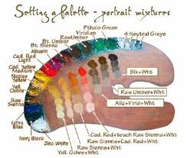
Image courtesy of wetcanvas.com

Dear Instructor:
We have taken every care to help you give the learner the best experience in Plein Air Painting with this beginning course. We hope your expertise and care will make the tradition of Plein Air continue in our students. Each Instructor is carefully chosen for their experience and teaching ability. Welcome to the Real Plein Air Studio!

Instructor will circulate, after assigning each learner a reference plein air painting to work from, to help designate the colors needed for each painting. Specifics cannot be designated here, as each will vary.

Phase II: Preparing the Canvas:

Courtesy webexhibits.org

Prepare the canvas as prescribed in basic effects in Imprimatura. The reference painting may cause the color choice to differ, but mid-tone browns, grays, and blue-grays are acceptable for imprimatur preparation. Students should already have this experience at their disposal, as required in the course description.

Large brushes are used to prepare the canvas. Regular painter’s brushes are acceptable for this section.

All imprimatur colors are at the discretion of the individual Instructor and the Learner.

Phase 3: Blocking In:

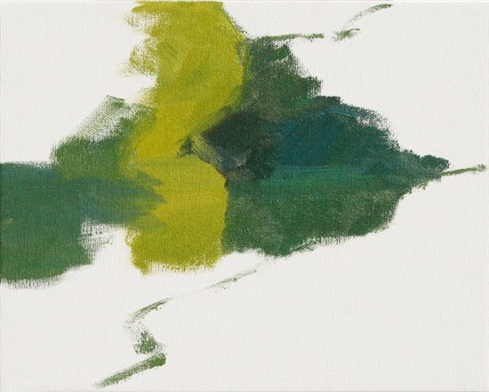
Image courtesy artistdaily.com/blogs/pleinair/archive

According to the particular reference painting, the sky, mountains, middle ground, and foreground will be blocked in.
The SME Instructor prefers that the sky be blocked in first, but this may vary according to Instructor. In this image, the mid-ground and foreground are blocked in at the same time due to the colors being analogous.

Phase 4: Block in Darks and Shadows:

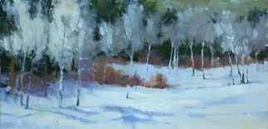
Image courtesy ofeldonwarren.wordpress.com

As each reference painting is different, darks will vary. Learners should be reminded to use a blue-gray mixture to block in darks, as the sky is reflected in the shadows and is the base for all outdoor shadows.

Working back to front, the Learners will paint according to the respective painting the Instructor has chosen for them according to skill level.

Shadows are lighter in the back according to visual perception, and are still a variation of blue-gray. (Students should be encouraged to keep enough blue-gray mixture on their palette for the whole class, so they do not have to re-mix it.)

Phase 5: Local Color:

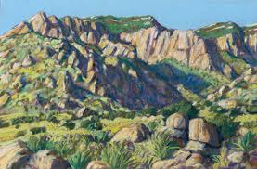
Image courtesy unm.edu

Depending on the reference painting, local color (which has been premixed according to the painting) should be applied at this time.

Remembering the law of “fat over lean” learners will be encouraged to not mix medium into their paint at this point. Remind the Learners that each painting has its own design, regardless of the scenery – that nature has rhythm, pace, and effect of its own.

It is not possible in actual Plein Air painting, to come away with every detail of the outdoors. A sense of the moment, what the student wants to convey, should be foremost.

Phase 6: Attend to Few Details:

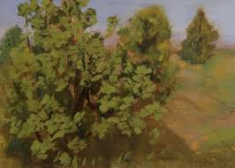
Image courtesy pleinairartistsinternational.blogspot.com

Checking the reference painting, the learner should add a few details. It is understood that the learner will not be seeing what the reference painting artist saw; however, rending some detail based on the painting will help the learner make the choices in their own plein air experience of which details to leave out and which to include.

This is a critical skill in plein air painting that cannot be overemphasized. Local color and reflected color should be considered in the choices made.

Phase 7: Wrap up/Clean Up:

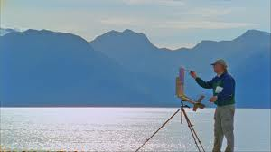
Image courtesy artistdaily.com

While Students are cleaning up, remind them to continue to pursue their studies in groups with peers, with plein air societies, by studying masters displayed in museums and galleries, and by reading books.

We encourage our Instructors to be true facilitators of talent, as well as mentors, as far as their capacity allows them. Any email or phone correspondence can be referred to the Studio, as it is understood that each Instructor has painting work of their own that has to come first.

Thank you for joining us.

*End of Instruction*

References:

Painter, A. (2011). The not for real website and book for learning plein air painting. Chicago, IL: Bold Books.

Plein air: Painting the American landscape. (2007). PBS.
http://www.pbs.org/programs/plein-air/

PLEIN AIR - Painting the American Landscape
http://youtu.be/b-vTPK5f5eY

